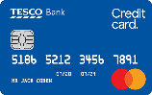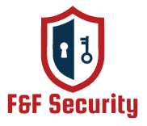

**Custom (Depends on user choice)**

|  |  |  |  |
| --- | --- | --- | --- |
| |  | | --- | |  | |  | |  | |
|  |
|  |

**Yearly (For one year)**

**$45**

|  |  |  |  |  |  |  |
| --- | --- | --- | --- | --- | --- | --- |
| |  |  |  |  | | --- | --- | --- | --- | | |  | | --- | | * **Unlimited folders and files can be given security daily.** | | * **High- level security.** | | * **Two-way authentication.** | | |  | |  | |
|  |
|  |

**Monthly (For one month)**

**$7**

|  |  |  |  |
| --- | --- | --- | --- |
| |  | | --- | | * **25 folders and 25 files can be given security daily.** | | * **Mid- level security.** | | * **Authentication.** | |
|  |
|  |

**Weekly (For one week)**

**$2**

|  |
| --- |
| * **15 folders and 15 files can be given security daily.** |
| * **Mid- level security.** |
| * **Authentication.** |

**Can be paid through**

**Our Subscription Plan (for future)**